DRAWING GRAPHS

Name: ____________________

Rules for making a line graph

1. Use a ruler and sharp lead pencil.

2. Draw a horizontal line at the bottom of the graph paper and a vertical line at the edge of the graph paper leaving room to write headings and numbers.

3. Where the two axis meet is the origin, mark it with a zero (O).

4. Work out which axis the dependent and independent variables go on.

5. Work out which scale to use, what numbers will you go up in? 5’s? 10’s? Etc.

6. Write a heading for each axis with the unit of measurement in brackets.

7. Write a title at the top of the graph. Dependent variable versus independent variable.

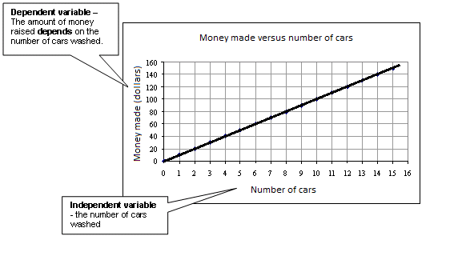

1. Every year a mother weighed her daughter from the day she was born. The data is shown in the table below.

Age (years) | Weight (Kg)
0 | 2.5
1 | 4
2 | 5
3 | 7
4 | 11
5 | 14
6 | 15
7 | 19
8 | 25
9 | 25
10 | 30
a) Look at the data. Is there a pattern occurring or is there just groups of things being compared with each other?

_______________________________________________________

_______________________________________________________

b) Is the table going to be a line graph or a bar graph?

_______________________________________________________



1. This table shows the number of human deaths caused by fires in Victoria, Australia.

Name of fire | Number of human deaths
Black Thursday bushfires | 12
Black Sunday bushfires | 2
Dandenongs bushfire | 3
Western Districts bushfires | 4

a) Look at the data. Is there a pattern occurring or is there just groups of things being compared with each other?

______________________________________________________________________________________

b) Is the table going to be a line graph or a bar graph? __________________________________________

